**ABSTRACT**

Air conditioning has enhanced work

efficiency and improved lifestyle by maintaining a comfortable

environment. The increased demand for air conditioning has a

detrimental effect on both electricity and the atmosphere. The

current air conditioning systems' low efficiency can be solved

by decoupling cooling and dehumidification processes, which is

enabled by an Indirect Evaporative Cooling (IEC) system.

Indirect evaporative cooling operates on the same principle as

direct evaporative cooling except that it reduces ambient

temperature by allowing water to evaporate. The primary

distinction between an indirect and direct system is that a heat

exchanger is used to cool the air supplied to the living space.

The evaporative cooling loop happens in the heat exchanger's

alternative channels (wet channels), which cools the air in

neighboring channels (dry channels) without introducing

moisture to it. Counter-flow heat exchangers are more efficient

than cross-flow heat exchangers, which are commercially

available in the market. The new concept addresses problems

with geometry, water distribution, working air injection, and

inadequate heat transfer. The IEC framework was planned to

be modular in order to facilitate commercialization. Wet Bulb

Effectiveness (WBE) was used as a parameter for evaluating

the performance of the IEC. The IEC can be coupled with air

conditioning systems to serve as a precooler.

**Chapter 1**

**INTRODUCTION**

One of the major reasons for low efficiency of air conditioning systems is coupling of sensible and latent heat removal processes in a single machine. An Indirect Evaporative Cooling system provides the most effective solution by decoupling cooling and dehumidification processes.

Indirect evaporative cooling works on the same principle as direct evaporative cooling - lowering air temperature by causing water to evaporate. The main difference with an indirect system is that a heat exchanger is used to cool the air supplied to the living space. The evaporative cooling cycle occurs in the heat exchanger.

Its energy requirements are very low as it does not involve use of compressors unlike conventional vapor compression refrigeration systems. The proposed design of Indirect Evaporative Cooling system includes counter-flow vertical plate type heat exchanger.

The counter-flow arrangement was considered as most efficient but it was not able to commercialize due to fabrication issues of pure counter-flow heat exchangers. Hence the cross- flow arrangement was commercialized successfully due to easy manufacturing but compromising on efficiency. So, we are trying to develop the design which is less complex to fabricate and can be used as reference for its commercialization at household level.

**PROBLEM STATEMENT**

Problems in earlier research and existing products based on indirect evaporative cooling are as follows:

1. Due to the incapability of geometry of heat exchanger surface and poor wettability in some cases of available products based on IEC the distribution of water over the surface of wet side of heat exchanger is poor. This result in accumulation of water at some places while dryness at some which reduces the total effective area and also if the thickness of layer of water increases both the evaporation and heat transfer rates decreases which in turn drastically reduces the efficiency and hampers the desired output.

2. When the working air is supplied at the single injection point or line, the cooling capacity of that air decrease before it reaches the end. Hence the potential of working air is not completely utilized and efficiency is reduced over the length.

3. Highly complex design to manufacture making it non ideal for commercialization.

4. In horizontal heat exchanger sagging causes reduction in air flow passage.

5. Poor heat transfer due to hydrophobic separation of dry and wet channels

**Objectives of Project**

1. To overcome problems in conventional or recent products based on Indirect Evaporative Cooling

2. To develop the design to achieve maximum efficiency

3. To reduce complexity of design and make it ideal for commercialization at household level

4. To create environment friendly design with low cost

5. To apply technical knowledge for real life problems

**Chapter 2**

**LITERATURE REVIEW**

V. Venka

teswara Rao et al. [1] conducted a feasibility assessment of single to multi/hybrid evaporative coolers for building air-conditioning across diverse climates in India. They assessed the potential of direct evaporative cooling (DEC), indirect evaporative cooling (IEC), direct expansion system (DX) and their different combinations (IEC-DEC, DEC-DX, IEC-DX, IEC- DEC-DX) for building air-conditioning of a 8-story residential building containing 32 flats for 21 cities belonging from five climatic zones in India. They found that the three-stage hybrid system including indirect evaporative cooling, direct evaporative cooling and direct expansion system has an energy saving potential up to 25%.

Trilok Singh Bisoniya et al. [2] conducted a comparative thermal analysis of theoretical and experimental studies of modified indirect evaporative cooler having cross flow heat exchanger with one fluid mixed and the other unmixed. They developed a heat and mass transfer mathematical model to simulate the properties of indirect evaporative cooler. The experiment carried out with different combinations of outside DBT, outside RH, recirculation of humid Exhaust air. They found that the indirect evaporative cooling is suitable in hot and humid climate without recirculation of return humid air. As in Indirect evaporative cooler no major input is required apart from energy to run fan and water pump, the coefficient of performance of this system is therefore likely to be high.

|  |  |  |  |  |  |  |
| --- | --- | --- | --- | --- | --- | --- |
| Sr.  No. | Out-Door Air Temperature (t1) | Out-door RH (%) | Temperature after sensible cooling (t2) | Recirculation of humid Exhaust air (%) | T.R    kJ/min. | Supply temperature (t4) |
| 1. | 38 | 30 | 27.98 | 12.4 | 0.2 | 25.46 |
| 2. | 40 | 25 | 28.53 | 23.5 | 0.3 | 24.93 |
| 3. | 42 | 20 | 28.91 | 33 | 0.4 | 24.41 |
| 4. | 45 | 15 | 29.77 | 42.4 | 0.5 | 23.89 |
| 5. | 48 | 10 | 30.28 | 50 | 0.6 | 23.36 |

Table No. 01

They conducted experimental analysis of performance of evaporative cooler at different atmospheric conditions. The table shows result for study of evaporative cooler at different out- door temperature and humidity. When the effectiveness of heat exchanger is kept constant, the difference in temperature outside air and of air leaving heat exchanger remains constant. So, with increase in outdoor dry-bulb temperature, the temperature obtained after sensible cooling increases to keep the difference of temperatures constant. With increasing outdoor dry bulb temperature (t1) and decreasing relative humidity (%), the percentage recirculation of return humidified air is increased to meet the fixed comfortable conditions inside the space to be cooled because in hot and dry summer weather conditions the relative humidity of outdoor air is less and to acquire the 55% relative humidity inside the room which is comfortable the percentage

recirculation of return humidified air is increased. They assumed that the effectiveness and humidification efficiency of the cross-flow heat-exchanger or cooler are 70% but experimentally it was found that the values are only 50%. So, the experimental values of effectiveness and humidification efficiency are 28.57% less as compared to the theoretical values assumed.

J.K. Jain et al. [3] analytically investigated energy saving potential of indirect evaporative cooler under Indian climates. Three Indian cities namely Delhi, Jodhpur and Bangalore representing three different climates were used for this study. They found that in hot and dry and composite climates it gives reduced energy usage. They studied that large difference exists between dry- bulb and wet-bulb temperatures, in many parts of the country. This offers an excellent opportunity for indirect evaporative cooling as an alternative to a conventional vapor compression-based air conditioner.

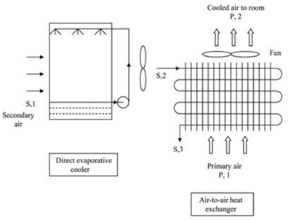

fig. 01

In indirect cooling, one stream of air called primary air is cooled sensibly with a heat exchanger, while the secondary air carries away the heat energy from the primary air. Atmospheric air, termed as secondary air, is cooled by DEC and then supplied to a heat exchanger. Air-to-air heat exchanger is used to cool primary air by secondary air. They concluded that an indirect evaporative cooler can be used to provide thermal comfort of occupants in buildings located in hot and dry and composite climatic zones of India. Performance of an indirect evaporative cooler

has been found to be almost same in both the climatic zones under consideration. Power saving in the month of May is found to be 600.78 and 643.87 KW for Delhi (composite climate) and Jodhpur (hot and dry climate), respectively. Maximum power saving is obtained between 13 and 17 hours. So, an indirect evaporative cooler can be an alternative for providing thermal comfort of occupants with reduced energy use in some parts of India.

Anandhakrishnan Vaidyanathan [4] patented systems and methods for indirect evaporative cooling and for two stage evaporative cooling which uses cross flow heat exchanger principle. It comprises of scalable indirect evaporative heat exchangers formed with polymer substrates that are treated to render one surface substantially hydrophilic while the other is substantially hydrophobic, with channels for passage of primary (cooled) and secondary (cooling) air streams between them. The objectives of the invention were to provide an

indirect evaporative cooling component (heat exchanger) which utilizes materials that do not promote harmful fungus in/bacterial growth, provide a scalable indirect evaporative cooling component, resulting in a scalable indirect/direct evaporative cooling component and to achieve two-stage evaporative cooling at lower cost and higher efficiency. The two-stage evaporative cooling apparatus of this invention is controlled through a controller. In one instance, microprocessor based controller although other processor-based controllers are within the scope of this invention. In that embodiment, the two-stage evaporative cooling apparatus includes one or more processors and one or more computer usable media with code embodied to control apparatus.

G. P. Maheshwari et al. [5] analytically evaluated energy saving potential of an indirect evaporative cooler. They concluded that IEC offers maximum reduction in cooling capacity amd peak power demands. However, the benefits of IEC are located oriented and change drastically from place to place. The energy savings were more in drier interior zones as compared to coastal areas.

Changhong Zhan et al. [6] conducted a numerical study of a M-cycle cross-flow heat exchanger for indirect evaporative cooling.

A computer model to simulate the thermal performance of a M-cycle cross-flow heat exchanger and detailed analysis of relation between the cooling (wet-bulb) effectiveness, system COP and air flow/exchanger operational parameters were done. This model was validated by experimental data. The new heat and mass exchanger achieves 16.7 % higher cooling Effectiveness compared to conventional cross-flow indirect Evaporative Cooler.

This exchanger can be extended to the large-scale central air handler units for energy savings. The model could be used in simulating the performance of other types of exchanger for indirect evaporative cooling.

The results of the study help with design and performance analysis of such type of indirect evaporative air cooler.

Valeriy Maisotsenko, Leland E. Gillan, Timothy L. Heaton, Alan D. Gillan [7] patented indirect evaporative cooling mechanism which uses cross flow heat exchanger with channel guides or corrugated plates. In evaporative cooling system the heat exchanger surface often was metal sheeting or plastic sheeting. The invention makes use of a combination or composite sheeting or plate to accomplish improved efficiency.

Robert William, David Mark, Nan, Shaun [8] patented a compact indirect evaporative cooler, which works on counter flow heat exchanger principle.

The system contained parallel heat exchanger plates with wet (hydrophilic) surface on one side and dry vapor resistant on other. The hydrophilic surface was kept continuously wet by spaying water. The water evaporated and was carried by working air thus extracting latent heat and cooling the plates.

Stefano De Antonellis et al. [9] experimentally studied the indirect evaporative cooler. An indirect Evaporative Cooler based on the principle of cross flow heat exchange was tested and modeled. The model takes into account the effects of the adiabatic cooling of the secondary air stream in the inlet plenum and the actual wettability of the heat exchanger surface. This cooling system can provide a significant reduction of primary air temperature.

Several tests were carried out to evaluate performance and the gathered data was used for calibration of model and its validation.

Simulations have been carried out to evaluate indirect evaporative cooling performance in different operating conditions, and it was found that the model can properly predict system performance in a wide range of operating conditions and also outside the calibration range. The model of the indirect evaporative cooler discussed in this work is based on the one proposed by Ren and Yang.

Muhammad Wakil Shahzada et al. [10] investigated an improved indirect evaporative cooler experiment. A generic cell was designed and tested at assorted weather conditions to investigate the performance. The experimental setup included long length counter flow heat exchanger with single dry channel surrounded by two wet channels and arrangement for efficient water and air flow. It was arranged in vertical manner (width side) for better wettability of hydrophilic membrane in wet channels.

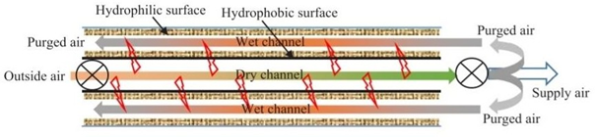

Generic cell process schematic diagram Fig. 02

The experimental analysis found that use of multipoint injection had better utilization factor rather than single injection of working air. Also, this configuration helps to overcome the issues of membranes sagging in horizontal heat exchangers design. The use of aluminum foil enhances the heat transfer rate and also prevents any biological organism growth.

Methodology

The Indirect Evaporative Cooler System was designed to overcome the problems stated above.

The preliminary idea was to create a box with vertical partitions such that channels would be created. The Supply Air (the air that would be sent to the conditioned spaces) would be sent from every alternate channel. The supply air would not come in contact with water at any position; hence it is named as a dry channel. In the remaining channels, named as wet channels, water is to be sprayed on the wall surfaces. The channels sprayed with water will be supplied with pre cooled air (working air).The wet channel surfaces will be covered by hydrophilic membranes. The supply air and working air will flow in opposite directions. The water will be sprayed at multiple points.

The materials and equipment required for the project were procured.

The materials were obtained after some small-scale experiments.These experiments were mainly for the piping systems.For equipment tests were carried out in the college labs.

Following the procurement of materials, procedures such as bending, brazing, and drilling were carried out in nearby fabrication workshops. The rest of the fabrication was completed in the college workshop.

Some adjustments were done in the design due to the problems encountered.

Also CFD Analysis was done .

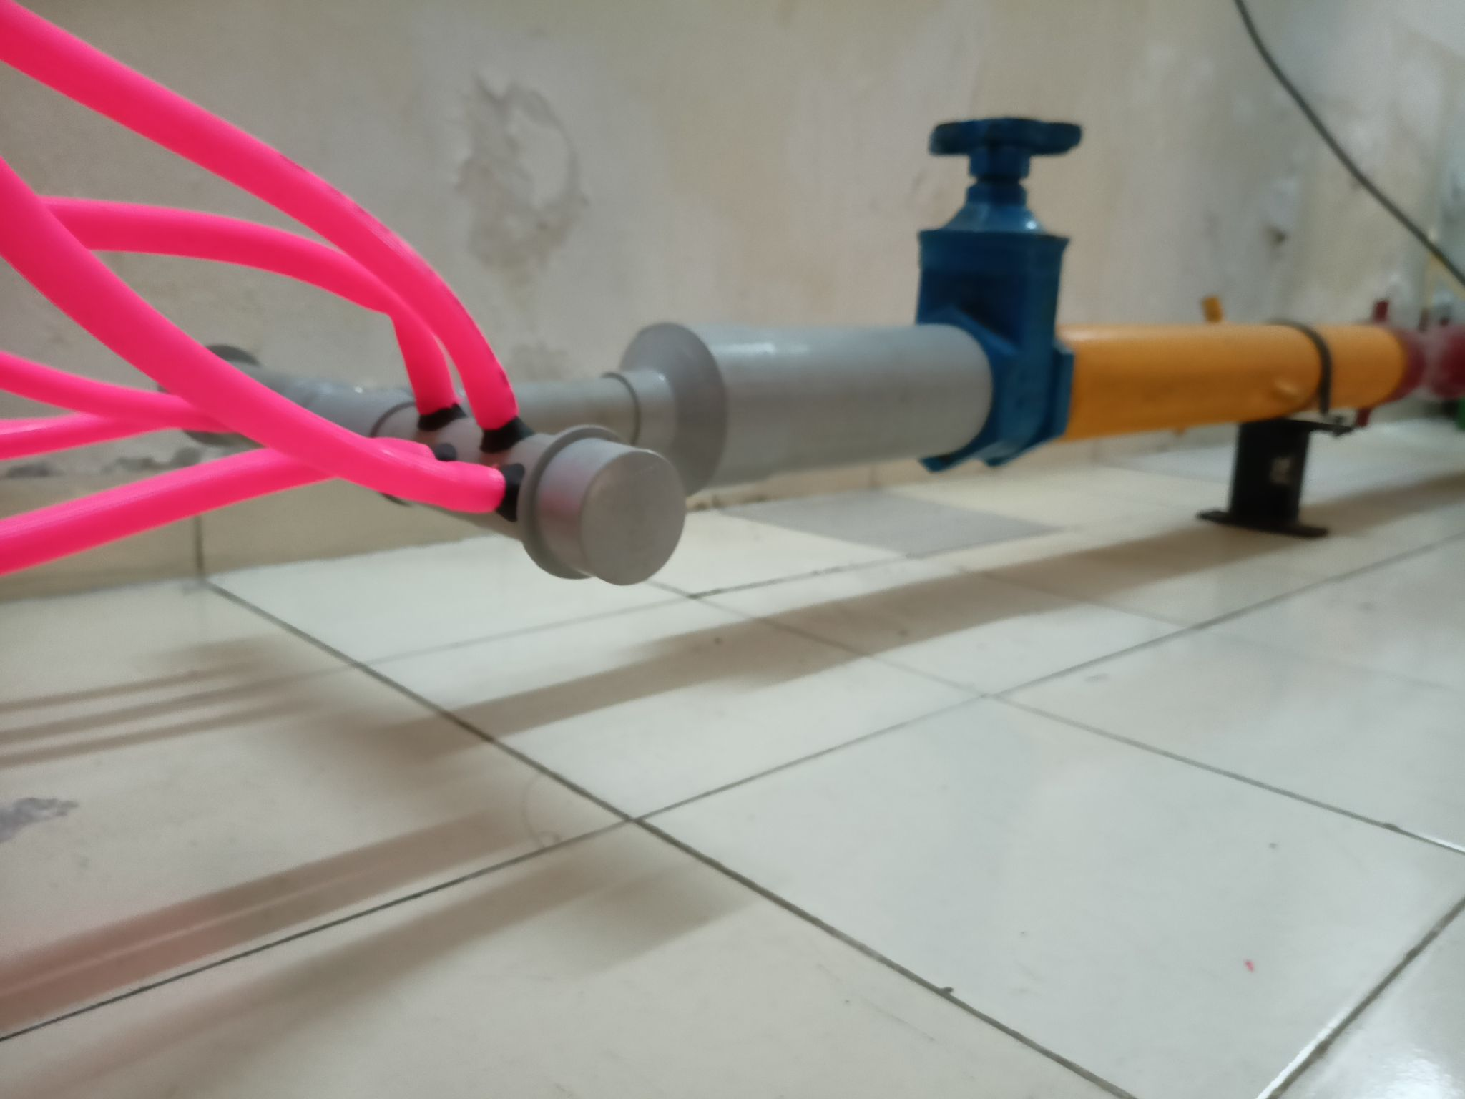

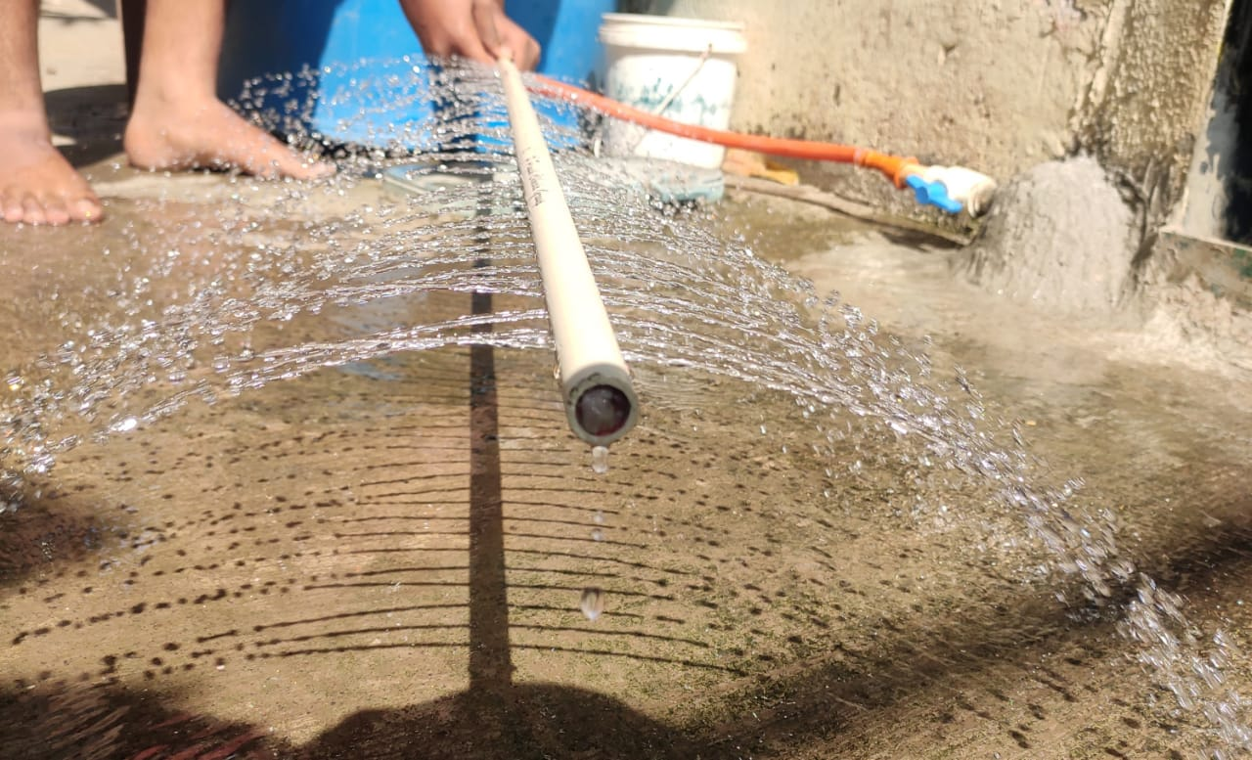

**Formulae used :**

WET BULB EFFECTIVENESS (WBE)

WBE = =

Effectiveness of counter flow heat exchanger : ∊HE =

|  |  |  |
| --- | --- | --- |
| **PARAMETER** | **DEC** | **IEC** |
| Air and water contact | Direct Contact | No Contact |
| Cooling Process | Adiabatic | Sensible |
| Decrease in DBT | ✔️ | ✔️ |
| Decrease in WBT | - | ✔️ |
| Increase in Moisture content | ✔️ | - |
| Decrease in Enthalpy | - | ✔️ |

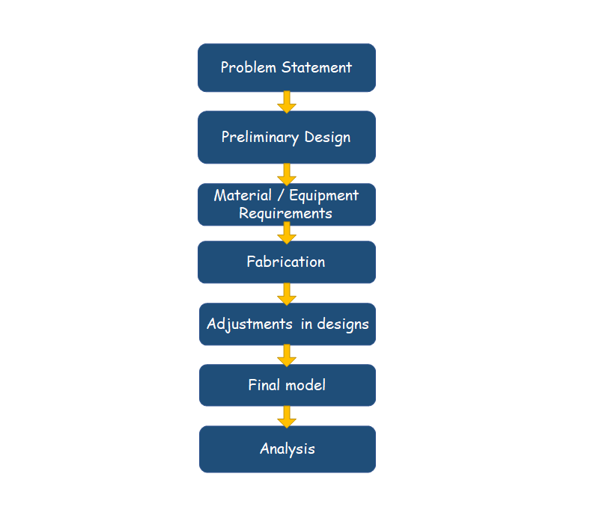

**Apparatus:**

The schematic of the IEC system is shown below.

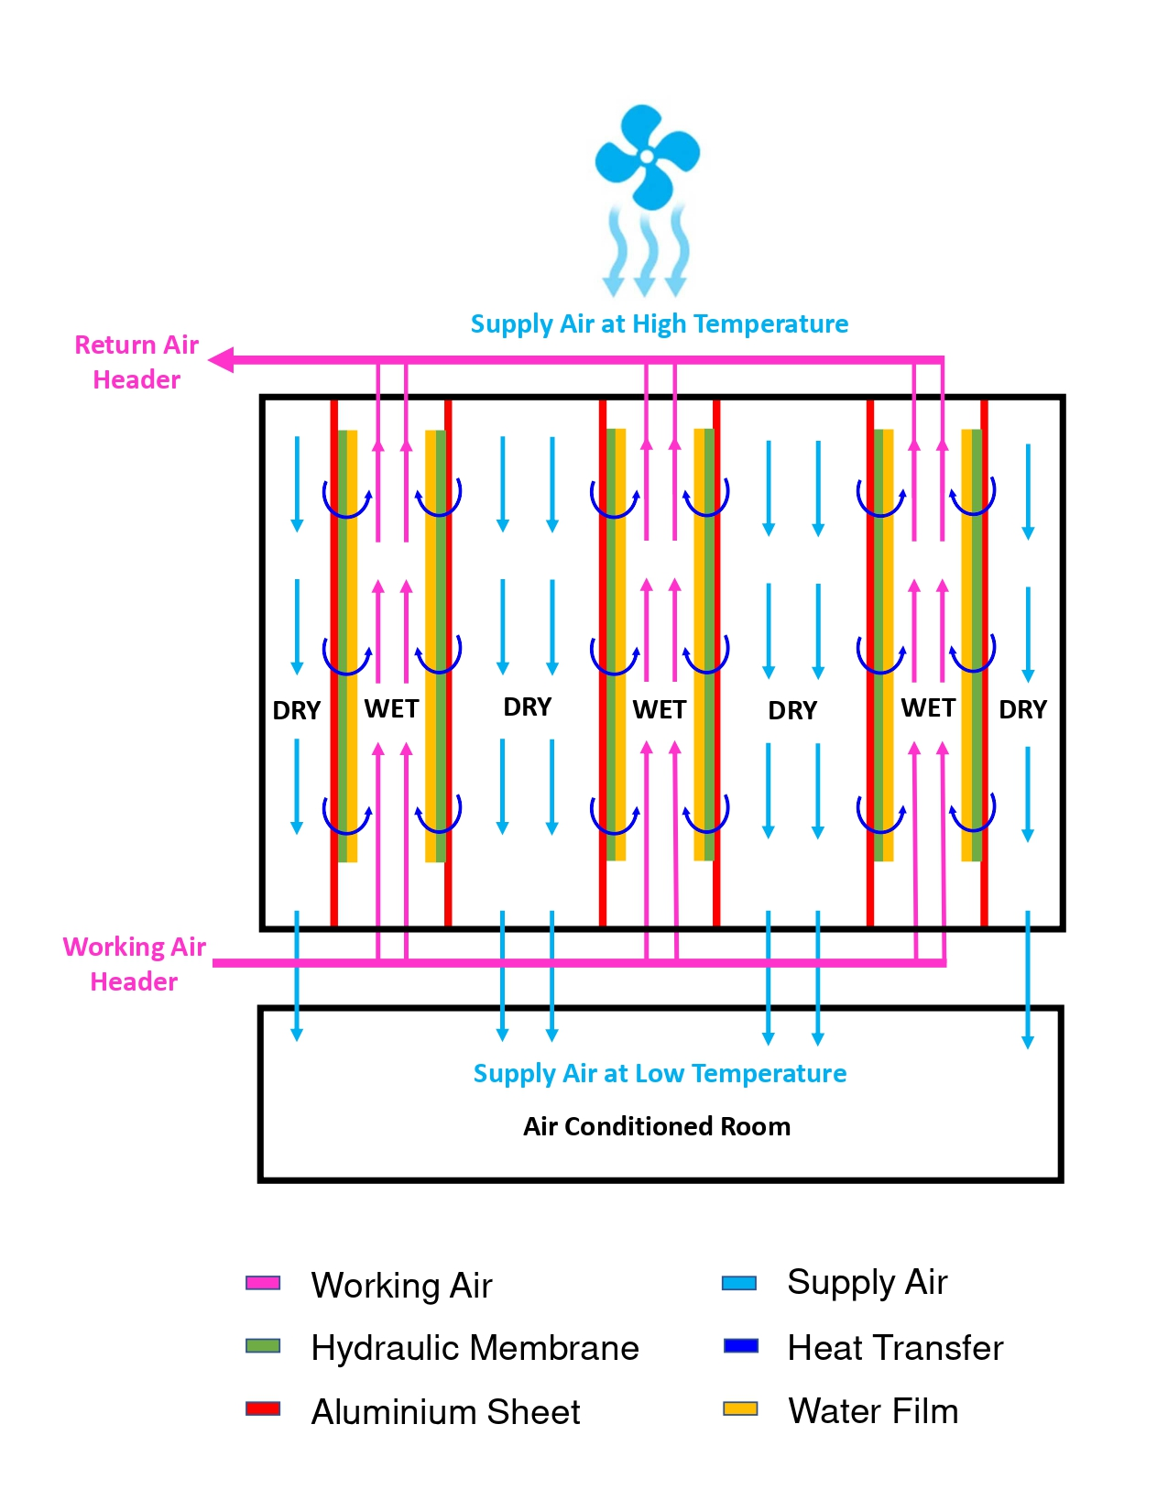

The partitions are made from aluminum sheets less than 1mm thick whereas the outer body of 2mm mild/stainless steel sheets are used. PVC pipes are used for water and air flow. The supply air is sent by the axial fan whereas the working air will be supplied by blower through pipes, Overhead tank will be used as a reservoir for water distribution.

|  |  |
| --- | --- |
|  | **Item** |
| **EQUIPMENTS** | Blower  Pump  Axial Fan |
| **MATERIALS** | Sheet Metal – Aluminum  Piping  Pipe Fittings  Sealant |

**Experimental Setup**

The images of the actual IEC system are shown below.

The IEC has a total length of 1000 mm and a height of 300 mm. The wet channel is 30 mm wide and the dry channel is 45 mm wide. At the bottom, there is a drain hole. Working air will be introduced at four points and ejected via a single point.

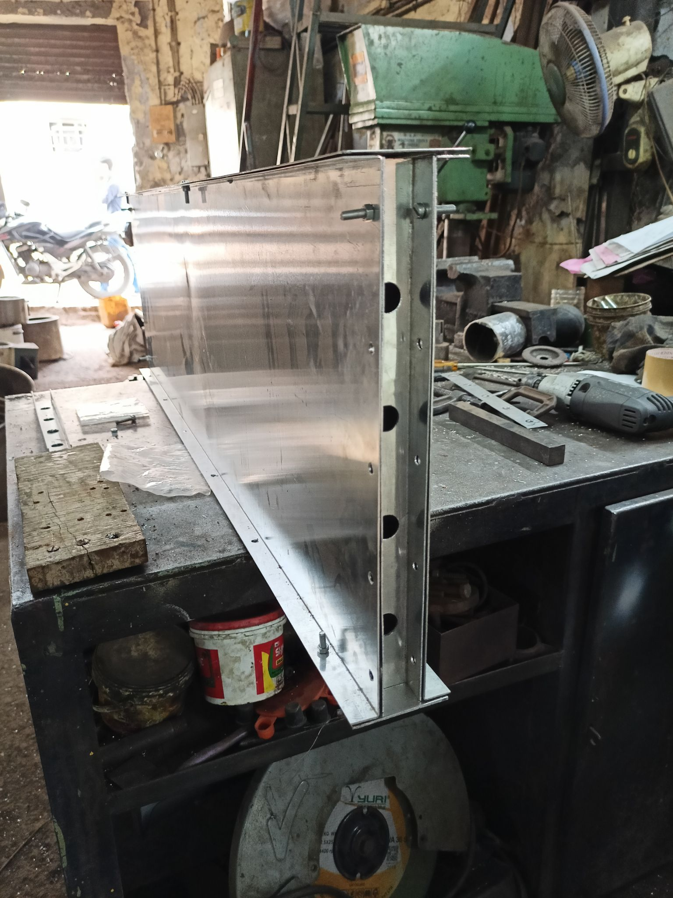

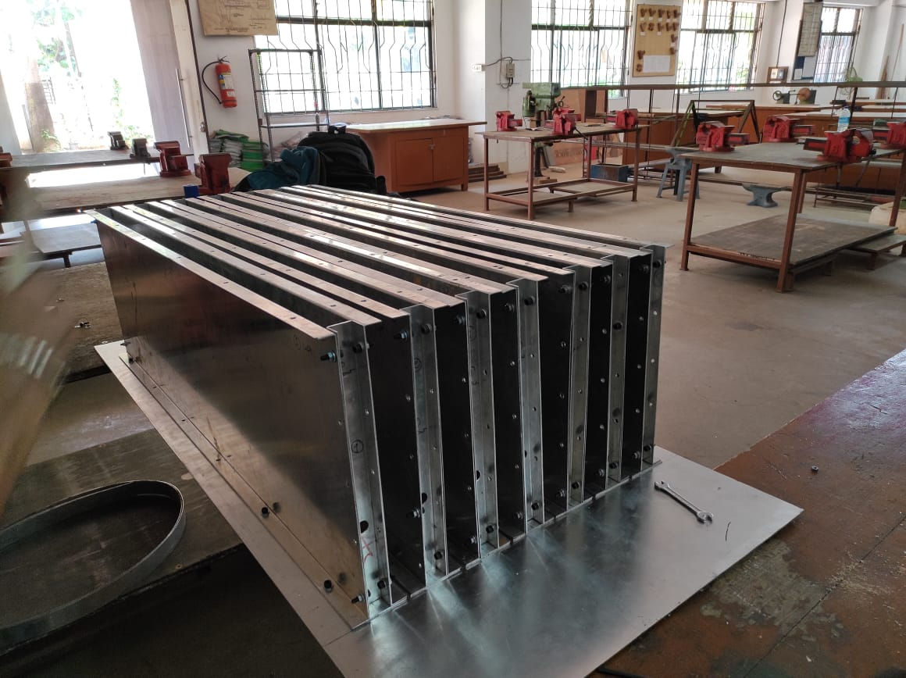

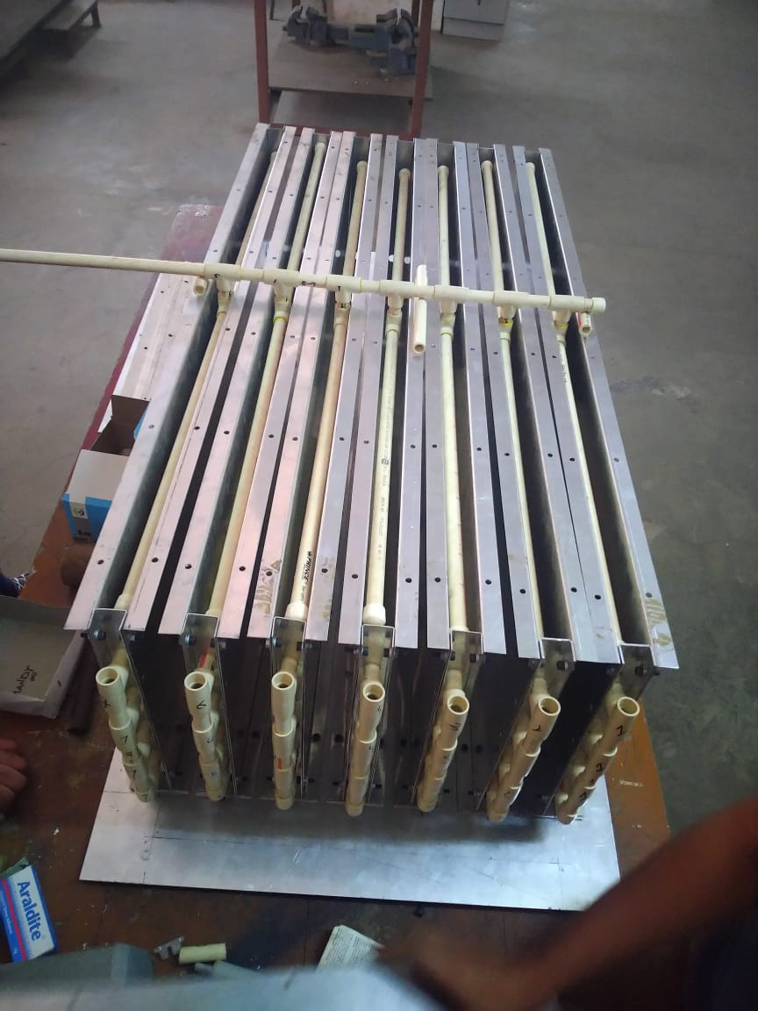

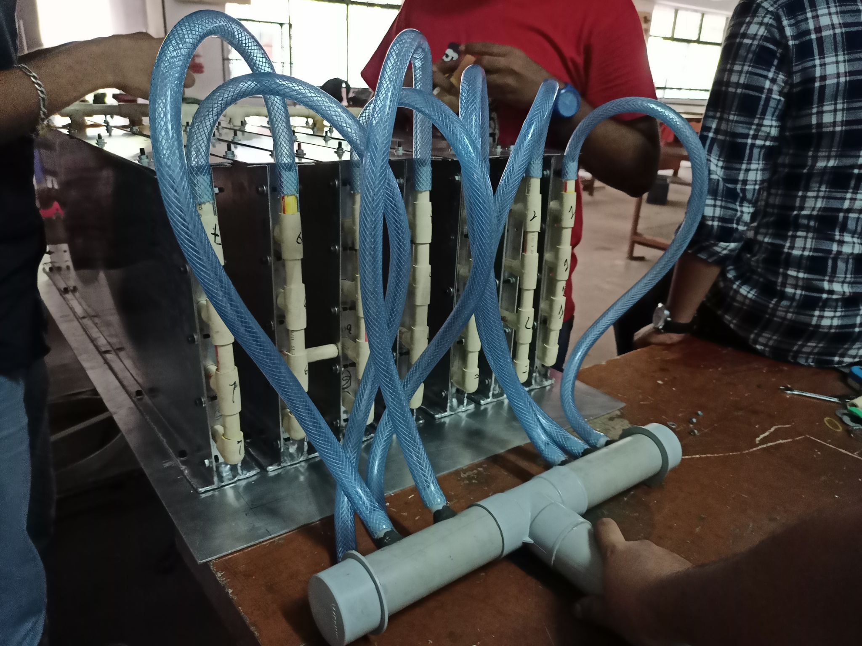

CFD SETUP

The Computational Fluid Dynamics (CFD) analysis were done for the heat exchanger process.

Assumptions:

The Temperature of the Working Air was assumed to be constant.

The Temperature of working air was calculated using the WET BULB EFFECTIVENESS (WBE)

supply to working air ratio = 0.5

Velocity for Working Air = 0.3 m/s

Velocity for Supply Air = 0.15 m/s

Model : 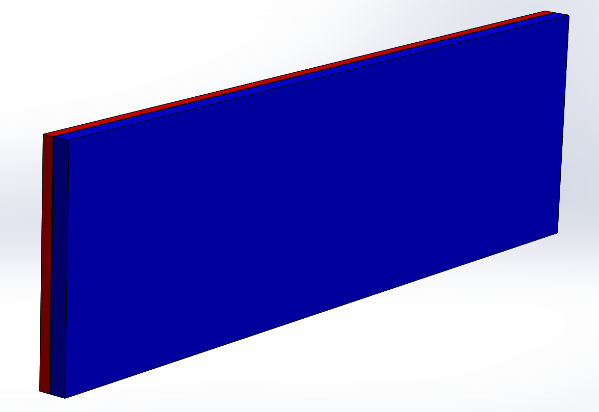

Mesh :

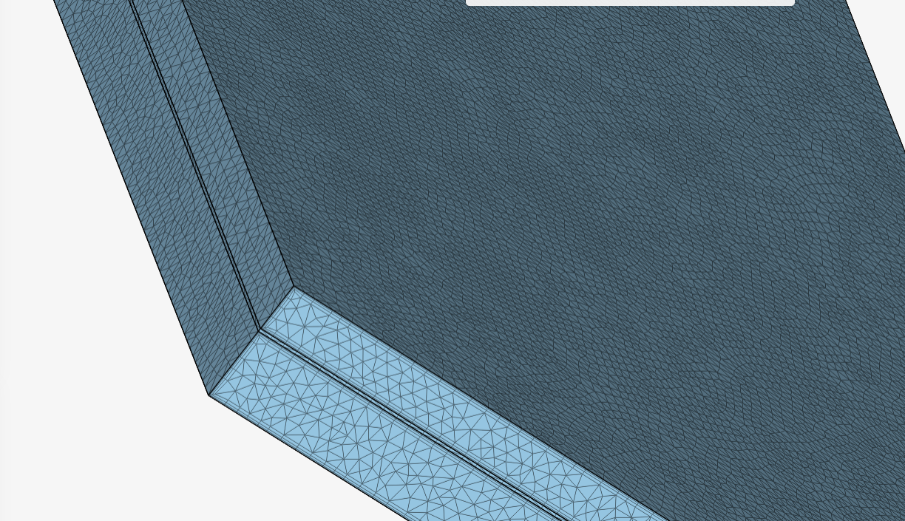

Inputs:

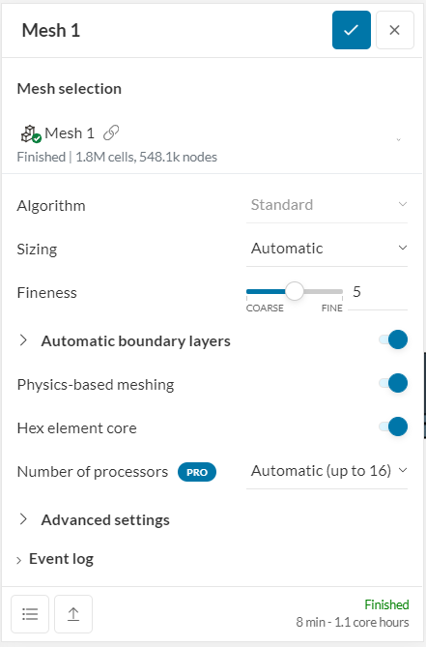

# OBSERVATIONS AND CALCULATIONS

The Calculation is divided into two parts:

1. The Evaporative Cooling in the Wet Channel
2. The heat transfer process between wet and dry channels

Considering,

90% wet bulb effectiveness in wet channel (direct evaporative cooling)

80% heat exchanger efficiency

@ supply to working air ratio = 0.5

Sample Calculation :

Calculations for koparkhairane :

Outside Conditions :

24th March 2021 @ 3:00 PM

(DBToutside )Koparkhairane = 33 C

(WBToutside )Koparkhairane= 21 C

**WET BULB EFFECTIVENESS (WBE)**

WBE = =

0.9 =

= = 23.33 °C

Effectiveness of counter flow heat exchanger : ∊HE =

= DBT of Working air = 24.75 °C

= DBT of entering supply air = 31.7 °C

= DBT of exiting supply air

∊HE = 0.8

∊HE =

0.8 =

= 25.264 °C

**Results**

The Results of CFD simulations are as a follows:

Supply Air:

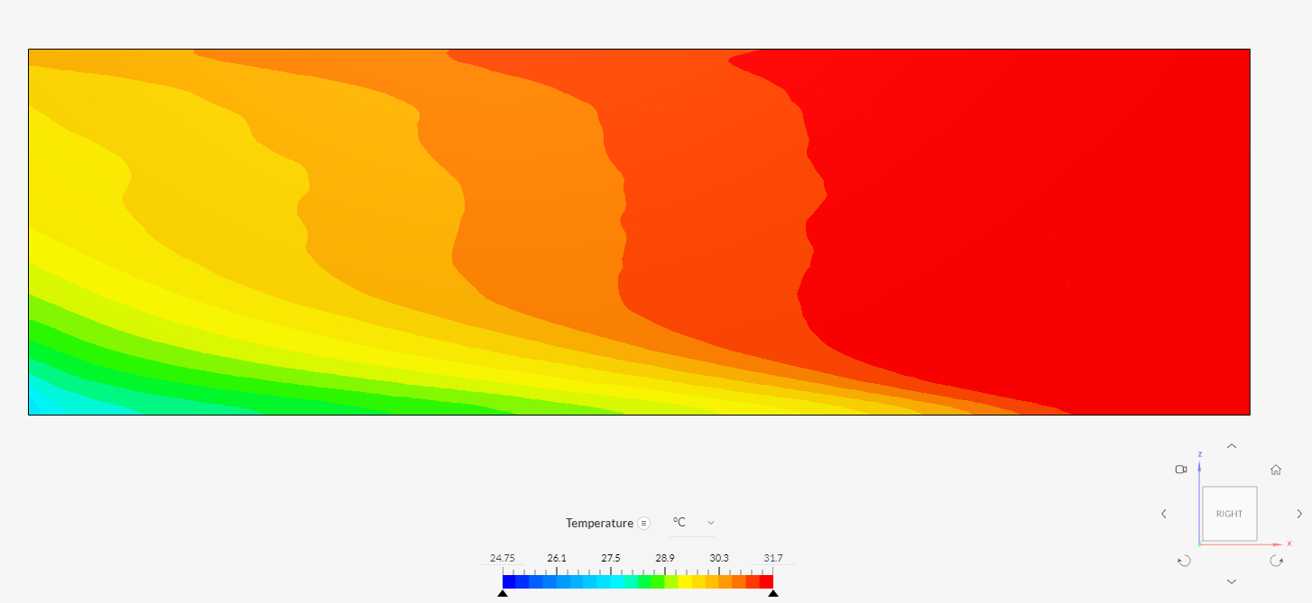

Working Air:

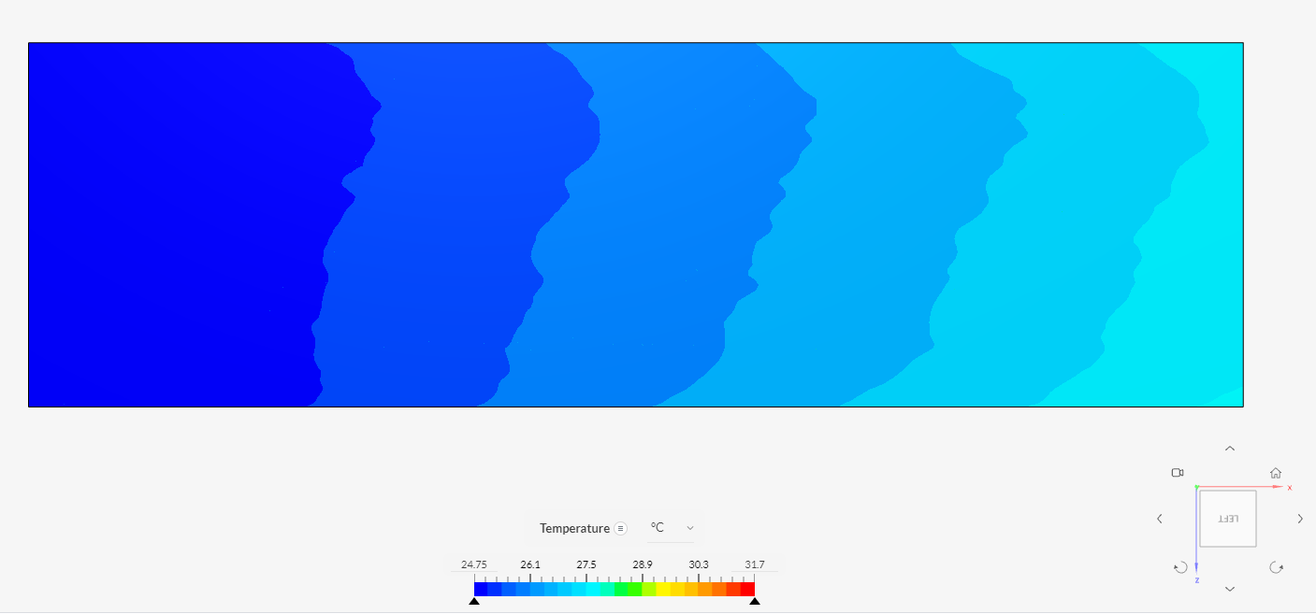

Top View: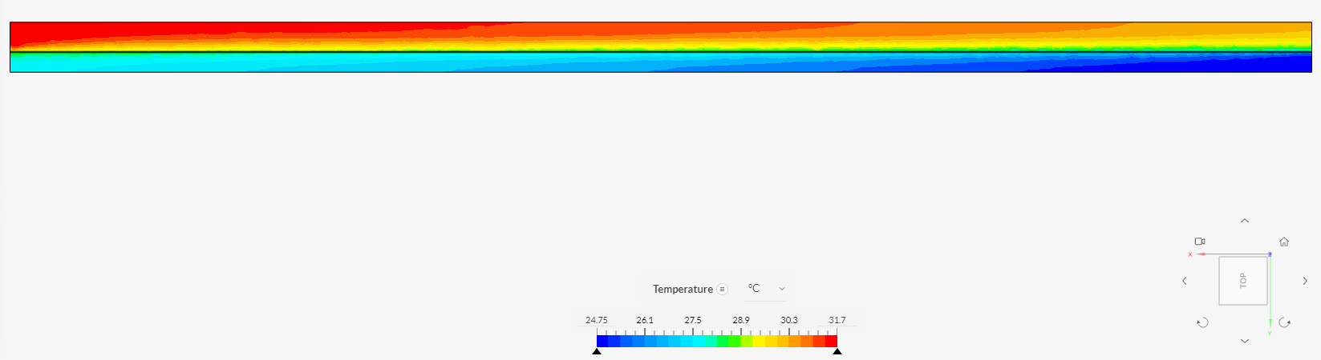

Section at 950mm from Working air Inlet:

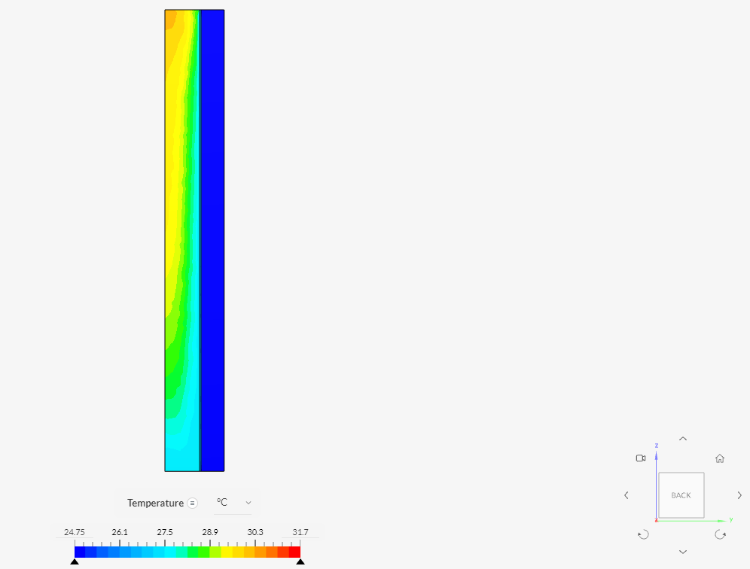

Analysis

The analysis was done for the different temperature regions in India except the cold regions.

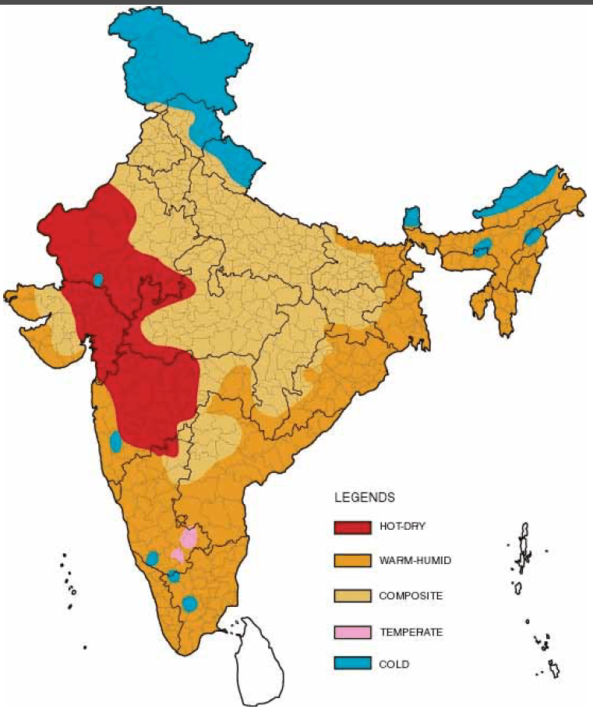

Considering

90% wet bulb effectiveness in wet channel (direct evaporative cooling)

80% heat exchanger efficiency

Month Considered : March

|  |  |  |  |  |  |  |  |
| --- | --- | --- | --- | --- | --- | --- | --- |
| **Climatic Zone** | **City** | **Time** | **DBT** | **WBT** | **Achievable DBT** | | **Total Achievable 🛆T** |
| **In Wet Side** | **With IEC** |
| Hot and Dry | Ahmedabad | 11:00 AM | 33.6 | 20.1 | 22.33 | 24.59 | 9.01 |
| 3:00 PM | 38.6 | 21.6 | 24.00 | 26.92 | 11.68 |
| Temperate | Bangalore | 11:00 AM | 27.5 | 16.4 | 18.22 | 20.08 | 7.42 |
| 3:00 PM | 21.7 | 17.8 | 19.78 | 20.16 | 1.54 |
| Warm and Humid | Mumbai | 11:00 AM | 30.2 | 20.5 | 22.78 | 24.26 | 5.94 |
| 3:00 PM | 32.2 | 21.1 | 23.44 | 25.20 | 7.00 |
| Composite | Nagpur | 11:00 AM | 34.4 | 18.2 | 20.22 | 23.06 | 11.34 |
| 3:00 PM | 39.3 | 19.8 | 22.00 | 25.46 | 13.84 |

From the above table it is evident that the Indirect Evaporative Cooling Systems are best suited for Temperate and Hot and Dry regions.

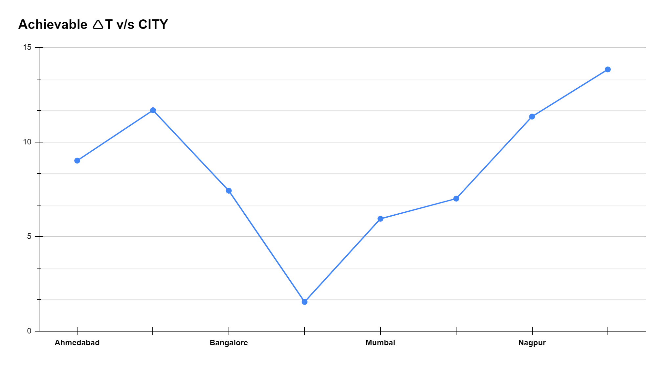

Conclusion :

The results obtained from the CFD simulations have differed slightly from the calculated temperatures.

The reasons for the deviation is the simplification of the model as well as the simulation setup not taking into account the process undergoing in the wet channels.

A complete analysis was also not performed due to a computational time limit.

It is expected that a further temperature drop of about 2-4°C can be achieved if the analysis is continued for further more time.

The further methods of optimization of design can be found out by actual experimentation as various factors are approximated in the simulation.

Future Scope

1. An improved Indirect Evaporative Cooling System that can achieve sustainable cooling goals.

2. The proposed design can be used as reference for its commercialization at household level.

3. It also can be used as a precooler in various air conditioning systems.

Air conditioning system with higher energy saving potential.

Rajput , R., 2015, Heat and Mass Transfer , S. Chand